[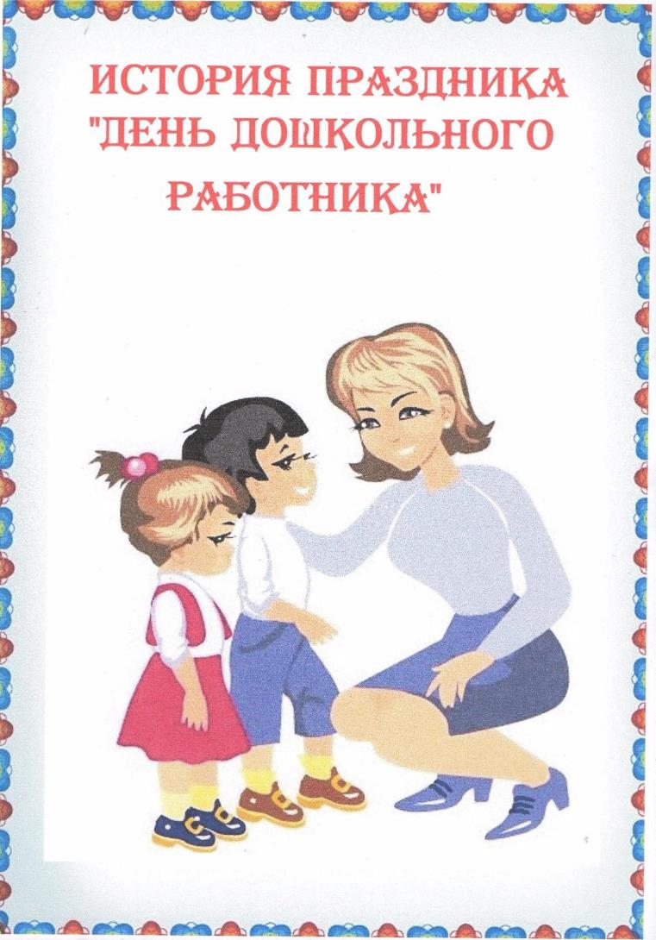](https://ok.ru/dk?cmd=PopLayerPhoto&st.layer.cmd=PopLayerPhotoOuter&st.layer.type=GROUP&st.layer.revNav=off&st.layer.limitedUi=false&st.layer.sphotoIds=858093203749;858093203493;858093203237;858093202981;858093202725&st.layer.showNav=on&st.layer.photoAlbumId=57809255923749&st.layer.epm=off&st.layer.photoId=858093203749&st.layer.opl=off&st.layer.navStartPhotoId=858093203749&st.layer.sbd=off&st.cmd=userMain&st._aid=GroupTopicLayer_openPhotoLayer)

[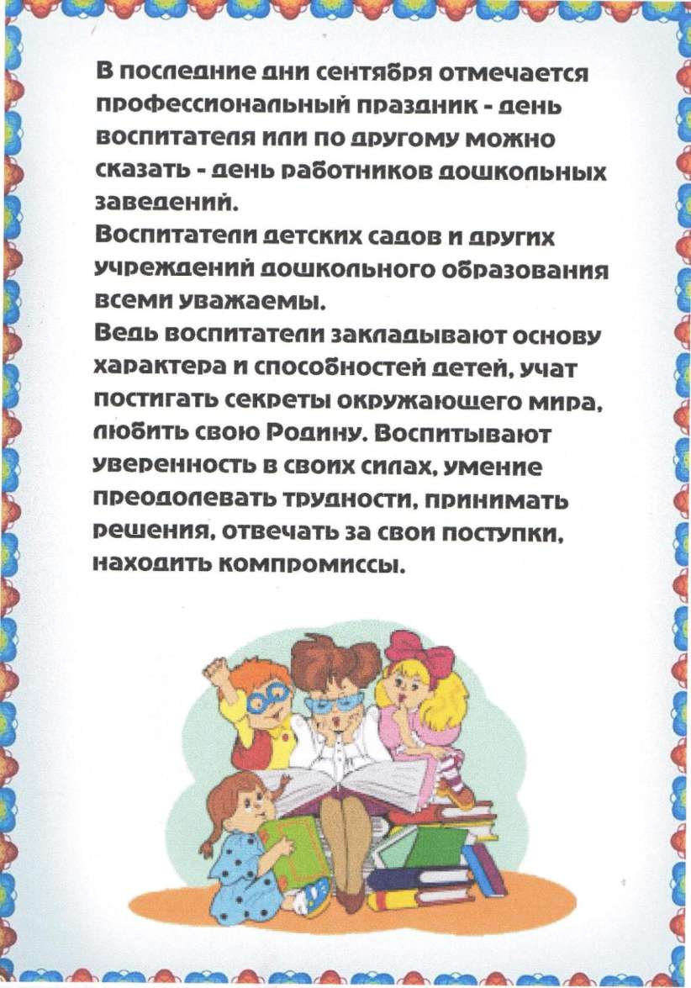](https://ok.ru/dk?cmd=PopLayerPhoto&st.layer.cmd=PopLayerPhotoOuter&st.layer.type=GROUP&st.layer.revNav=off&st.layer.limitedUi=false&st.layer.sphotoIds=858093203749;858093203493;858093203237;858093202981;858093202725&st.layer.showNav=on&st.layer.photoAlbumId=57809255923749&st.layer.epm=off&st.layer.photoId=858093203493&st.layer.opl=off&st.layer.navStartPhotoId=858093203493&st.layer.sbd=off&st.cmd=userMain&st._aid=GroupTopicLayer_openPhotoLayer)

[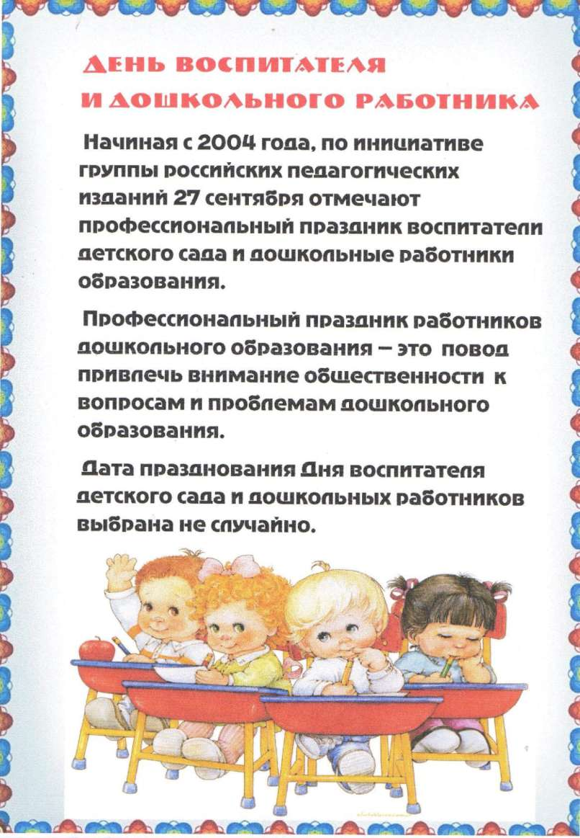](https://ok.ru/dk?cmd=PopLayerPhoto&st.layer.cmd=PopLayerPhotoOuter&st.layer.type=GROUP&st.layer.revNav=off&st.layer.limitedUi=false&st.layer.sphotoIds=858093203749;858093203493;858093203237;858093202981;858093202725&st.layer.showNav=on&st.layer.photoAlbumId=57809255923749&st.layer.epm=off&st.layer.photoId=858093203237&st.layer.opl=off&st.layer.navStartPhotoId=858093203237&st.layer.sbd=off&st.cmd=userMain&st._aid=GroupTopicLayer_openPhotoLayer)

[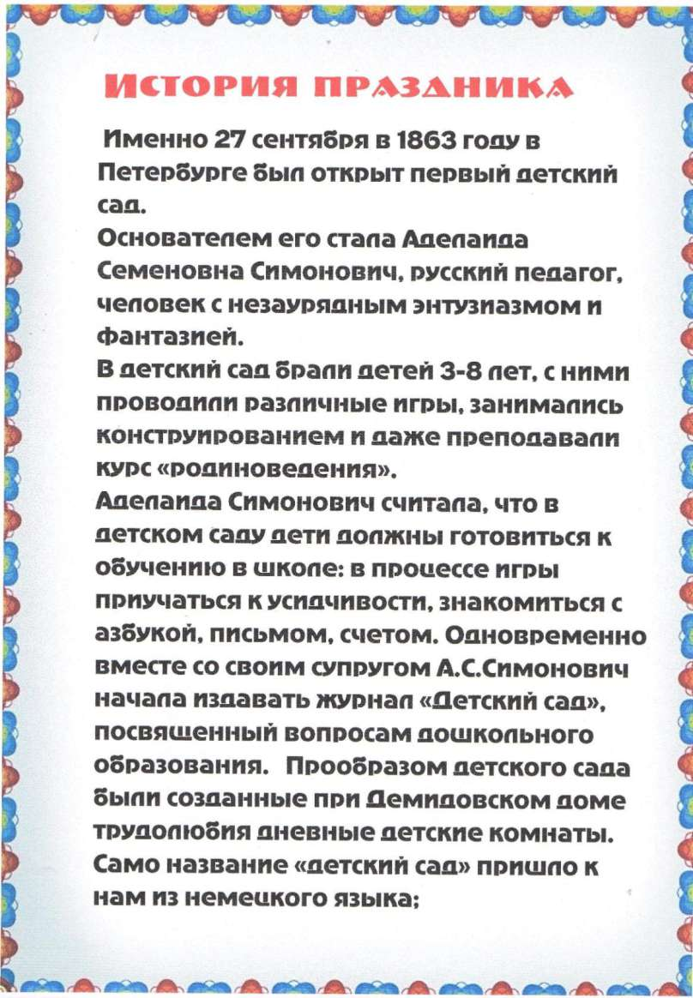](https://ok.ru/dk?cmd=PopLayerPhoto&st.layer.cmd=PopLayerPhotoOuter&st.layer.type=GROUP&st.layer.revNav=off&st.layer.limitedUi=false&st.layer.sphotoIds=858093203749;858093203493;858093203237;858093202981;858093202725&st.layer.showNav=on&st.layer.photoAlbumId=57809255923749&st.layer.epm=off&st.layer.photoId=858093202981&st.layer.opl=off&st.layer.navStartPhotoId=858093202981&st.layer.sbd=off&st.cmd=userMain&st._aid=GroupTopicLayer_openPhotoLayer)

[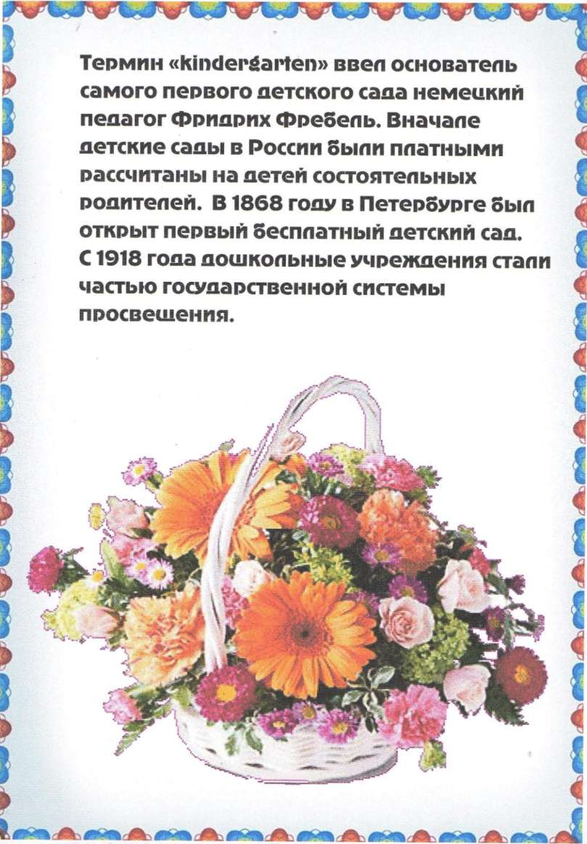](https://ok.ru/dk?cmd=PopLayerPhoto&st.layer.cmd=PopLayerPhotoOuter&st.layer.type=GROUP&st.layer.revNav=off&st.layer.limitedUi=false&st.layer.sphotoIds=858093203749;858093203493;858093203237;858093202981;858093202725&st.layer.showNav=on&st.layer.photoAlbumId=57809255923749&st.layer.epm=off&st.layer.photoId=858093202725&st.layer.opl=off&st.layer.navStartPhotoId=858093202725&st.layer.sbd=off&st.cmd=userMain&st._aid=GroupTopicLayer_openPhotoLayer)